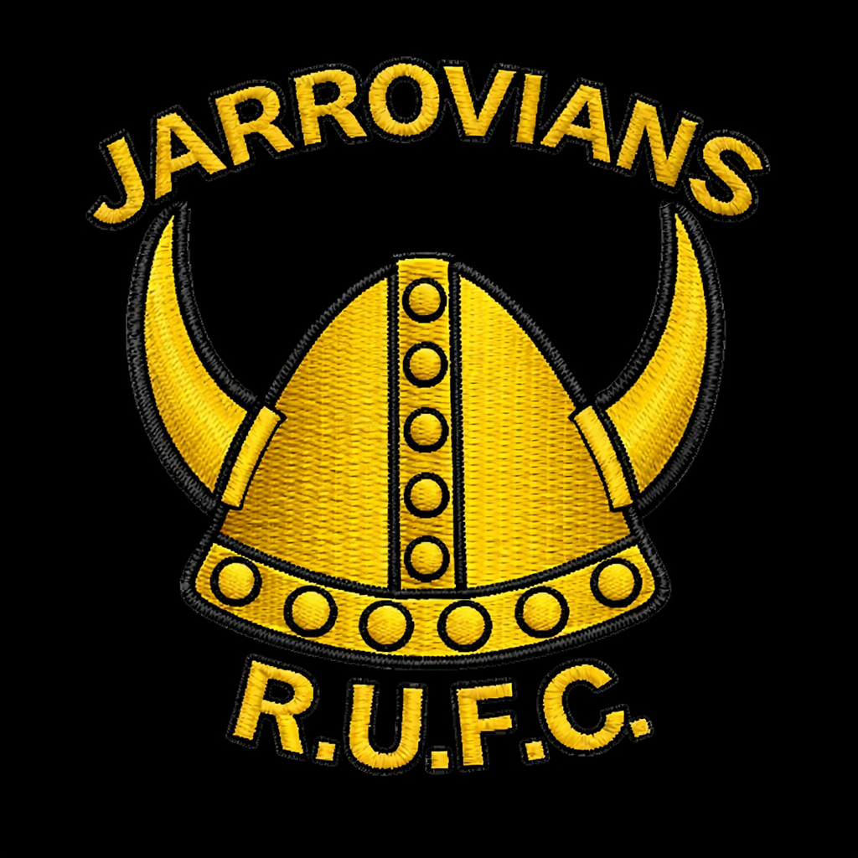

Jarrovian’s RUFC
U12/13’s
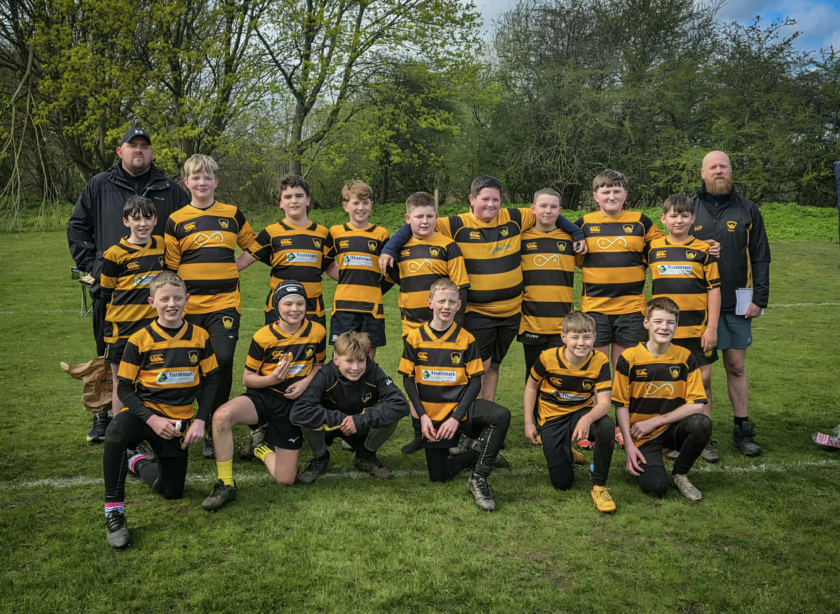
Season 2025/2026

“Iron Sharpens Iron, Together we Stand and we Fight.”


Thomas Page(Cap), Jacob Vacher(VC), DJ Rowan(VC), Jae Mason, Lewis Dent, Seb Baird, Charlie Dobson, Matthew Cordial, Jude Allen, Isaac Allen, Logan Lee, Finley Lee, Oscar Ayre, Harrison Carlin, Alex Norton, James Charlton, Connor Chapman, Max Morrison, Zack Clark, Ethan McShane & Angus Falconer.


